Experiment Details

|  |  |
| --- | --- |
| Department Name | Civil and Environmental Engineering |
| Class | Second year |
| Semester | Third |
| Subject Name | Material Testing Laboratory |
| Experiment No. | 01 |
| Experiment Name | Particle Size Distribution of Fine Aggregates. |

Version History

|  |  |  |  |  |
| --- | --- | --- | --- | --- |
| Sr. No. | Version Number | Created By | Approved By | Date |
| 1 | v1.1 | Saie Dhavale | Sourabh Joshi | 16/10/2020 |
|  |  |  |  |  |

AIM:

To determine fineness modulus of fine aggregate and classifications based on IS: 383-1970.

THEORY:

Sand having a fineness modulus more than 3.2 will be unsuitable for making satisfactory concrete. This is the name given to the operation of dividing a sample of aggregate into various fractions each consisting of particles of the same size. The sieve analysis is conducted to determine the particle size distribution in a sample of aggregate, which we call gradation. Many a time, fine aggregates are designated as coarse sand, medium sand and fine sand. These classifications do not give any precise meaning. What the supplier terms as fine sand may be really medium or even coarse sand. To avoid this ambiguity fineness modulus could be used as a yard stick to indicate the fineness of sand. The following limits may be taken as guidance: Fine sand: Fineness Modulus: 2.2 - 2.6, Medium sand: F.M: 2.6 - 2.9, Coarse sand : F.M. : 2.9 - 3.2

APPARATUS:

Test Sieves conforming to IS : 460-1962 Specification of 4.75 mm, 2.36 mm, 1.18 mm, 600 micron, 300 micron, 150 micron, Balance, Gauging Trowel, Stop Watch, etc.

PRE TEST:

1. How many types of fine aggregates are based on source?
   1. One
   2. Two
   3. **Three**
   4. Four
2. According to geological origin, aggregates is/are classified into __________ types.  
   a) 1  
   **b) 2**c) 3  
   d) 4
3. The aggregate sample for the sieve analysis is placed on:  
   **a) Largest sieve**  
   b) Smallest sieve  
   c) 40mm IS sieve  
   d) 4.75mm IS sieve
4. According to size, aggregates is/are classified into __________ types.  
   a) 1  
   b) 2  
   c) 3  
   **d) 4**
5. In how many ways can sieve analysis be carried out?  
   **a) 5**b) 2  
   c) 3  
   d) 4
6. What is the size of fine aggregates?  
   a) 4.75mm  
   **b) < 4.75mm**c) > 4.75mm  
   d) 12mm

PROCEDURE:

1. The sample shall be brought to an air-dry condition before weighing and sieving. The air-dry sample shall be weighed and sieved successively on the appropriate sieves starting with the largest. Care shall be taken to ensure that the sieves are clean before use.

2. The shaking shall be done with a varied motion, backward sand forwards, left to right, circular clockwise and anti-clockwise, and with frequent jarring, so that the material is kept moving over the sieve surface in frequently changing directions.

3. Material shall not be forced through the sieve by hand pressure. Lumps of fine material, if present, may be broken by gentle pressure with fingers against the side of the sieve.

4. Light brushing with a fine camel hair brush may be used on the 150-micron and 75-micron IS Sieves to prevent aggregation of powder and blinding of apertures.

5. On completion of sieving, the material retained on each sieve, together with any material cleaned from the mesh, shall be weighed.

OBSERVATION TABLE:

|  |  |  |  |  |  |
| --- | --- | --- | --- | --- | --- |
| IS Sieve | Weight Retained on Sieve (gm) | Percentage of Weight Retained (%) | Percentage of Weight Passing (%) | Cumulative Percentage of Passing (%) | Remark |
| 4.75 mm |  |  |  |  |  |
| 2.36 mm |  |  |  |  |  |
| 1.18 mm |  |  |  |  |  |
| 300 micron |  |  |  |  |  |
| 150 micron |  |  |  |  |  |
| Total |  |  |  |  |  |

CALCULATION:

Fineness modulus is an empirical factor obtained by adding the cumulative percentages of aggregate retained on each of the standard sieves ranging from 4.75 mm to 150 micron and dividing this sum by an arbitrary number 100.

Fineness Modulus FM= ($Total Cummulative Percentage of Passing)÷100$

CONCLUSION / RESULT

1. Fineness modulus of a given sample of fine aggregate is …….. that indicate Coarse sand/ Medium sand/ Fine sand.

2. The given sample of fine aggregate is belong to Grading Zones I / II / III / IV.

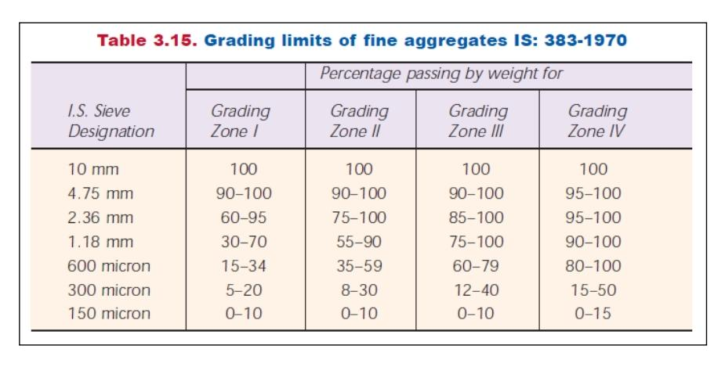POST TEST:

1. A narrow gradation is also called:  
   a) Gap gradation  
   **b) Uniform gradation**  
   c) Rich gradation  
   d) Open gradation
2. Gradation affects the properties of an aggregate.  
   **a) True**  
   b) False
3. Which of the below is a limitation of performing sieve analysis?  
   a) Time consuming  
   b) Costly  
   **c) Particle shape**d) Particle size
4. Aggregate crushed before the application of full load of ___________  
   a) 10ton  
   b) 20ton  
   c) 30ton  
   **d) 40ton**
5. Which type of aggregate is shown below?  
   [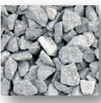](https://www.sanfoundry.com/wp-content/uploads/2017/11/concrete-technology-questions-answers-classification-aggregates-q8.png)  
   a) Angular aggregate  
   b) Rounded aggregate  
   **c) Flaky aggregate**  
   d) Irregular or partially aggregate